VISVESVARAYA TECHNOLOGICAL UNIVERSITY

**“JnanaSangama”, Belgaum -590014, Karnataka.**

**LAB REPORT**

**On**

**ANALYSIS AND DESIGN OF ALGORITHMS**

**(23CS4PCADA)**

**Submitted by**

**BHOOMIKA M (1BM23CS068)**

**in partial fulfillment for the award of the degree of BACHELOR OF ENGINEERING**

**in**

**COMPUTER SCIENCE AND ENGINEERING**



**B.M.S. COLLEGE OF ENGINEERING**

**(Autonomous Institution under VTU) BENGALURU-560019**

**February-May 2025**

**B. M. S. College of Engineering,**

**Bull Temple Road, Bangalore 560019**

**(Affiliated To Visvesvaraya Technological University, Belgaum)**

**Department of Computer Science and Engineering**



This is to certify that the Lab work entitled **“ANALYSIS AND DESIGN OF ALGORITHMS”** carried out by Bhoomika M **(1BM23CS068)**, who is a bonafide student of **B. M. S. College of Engineering**. It is in partial fulfillment for the award of **Bachelor of Engineering in Computer Science and Engineering** of the Visvesvaraya Technological University, Belgaum during the year 2024-25. The Lab report has been approved as it satisfies the academic requirements in respect of Analysis and Design of Algorithms Lab - **(23CS4PCADA)** work prescribed for the said degree.

**Prof. Anusha Dr. Kavitha Sooda**

Assistant Professor Professor and Head

Department of CSE Department of CSE, Bengaluru BMSCE, Bengaluru BMSCE

**Index Sheet**

|  |  |  |
| --- | --- | --- |
| **Sl.**  **No.** | **Experiment Title** | **Page No.** |
| 1 | Write a program to obtain the Topological ordering of vertices in a given digraph.  LeetCode Program related to Topological sorting | 5 |
| 2 | Implement Johnson Trotter algorithm to generate permutations. | 9 |
| 3 | Sort a given set of N integer elements using Merge Sort technique and compute its time taken. Run the program for different values of N and record the time taken to sort.  LeetCode Program related to sorting. | 11 |
| 4 | Sort a given set of N integer elements using Quick Sort technique and compute its time taken.  LeetCode Program related to sorting. | 15 |
| 5 | Sort a given set of N integer elements using Heap Sort technique and compute its time taken. | 19 |
| 6 | Implement 0/1 Knapsack problem using dynamic programming.  LeetCode Program related to Knapsack problem or Dynamic Programming. | 22 |
| 7 | Implement All Pair Shortest paths problem using Floyd’s algorithm. LeetCode Program related to shortest distance calculation. | 26 |
| 8 | Find Minimum Cost Spanning Tree of a given undirected graph using Prim’s algorithm.  Find Minimum Cost Spanning Tree of a given undirected graph using Kruskal’s algorithm. | 29 |

|  |  |  |
| --- | --- | --- |
| 9 | Implement Fractional Knapsack using Greedy technique. LeetCode Program related to Greedy Technique algorithms. | 34 |
| 10 | From a given vertex in a weighted connected graph, find shortest paths to other vertices using Dijkstra’s algorithm. | 37 |
| 11 | Implement “N-Queens Problem” using Backtracking. | 40 |

**Course outcomes:**

|  |  |
| --- | --- |
| CO1 | Analyze time complexity of Recursive and Non-recursive algorithms using asymptotic notations. |
| CO2 | Apply various design techniques for the given problem. |
| CO3 | Apply the knowledge of complexity classes P, NP, and NP-Complete and prove certain problems are NP-Complete |
| CO4 | Design efficient algorithms and conduct practical experiments to solve problems. |

**Lab program 1:**

**Write a program to obtain the Topological ordering of vertices in a given digraph.**

**Code:**

#include <stdio.h> #define MAX 100

int adj[MAX][MAX], n, visited[MAX], stack[MAX], top = -1; void dfs(int v) {

visited[v] = 1;

for (int i = 0; i < n; i++)

if (adj[v][i] && !visited[i]) dfs(i);

stack[++top] = v;

}

void topologicalSort() { for (int i = 0; i < n; i++)

if (!visited[i]) dfs(i);

while (top >= 0)

printf("%d ", stack[top--]);

}

int main() {

int edges, u, v;

printf("Enter number of vertices and edges: "); scanf("%d %d", &n, &edges);

for (int i = 0; i < edges; i++) {

scanf("%d %d", &u, &v);

adj[u][v] = 1;

}

printf("Topological Order: "); topologicalSort();

return 0;

}

**Result:**

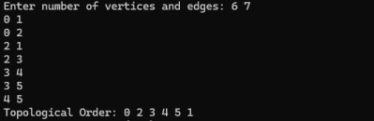

**Algorithm and Tracing Screenshot:**

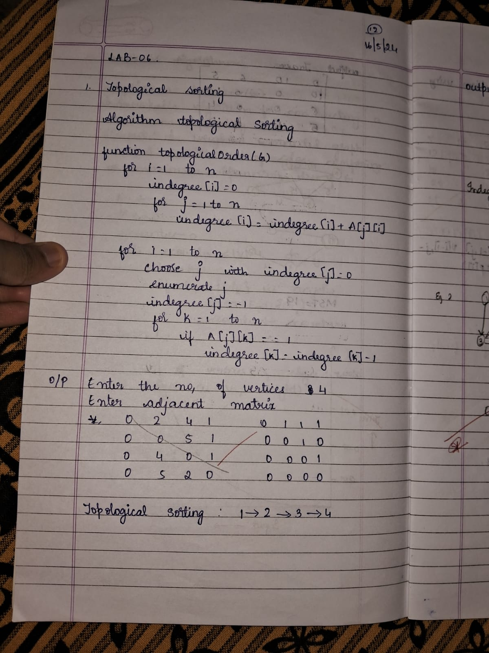 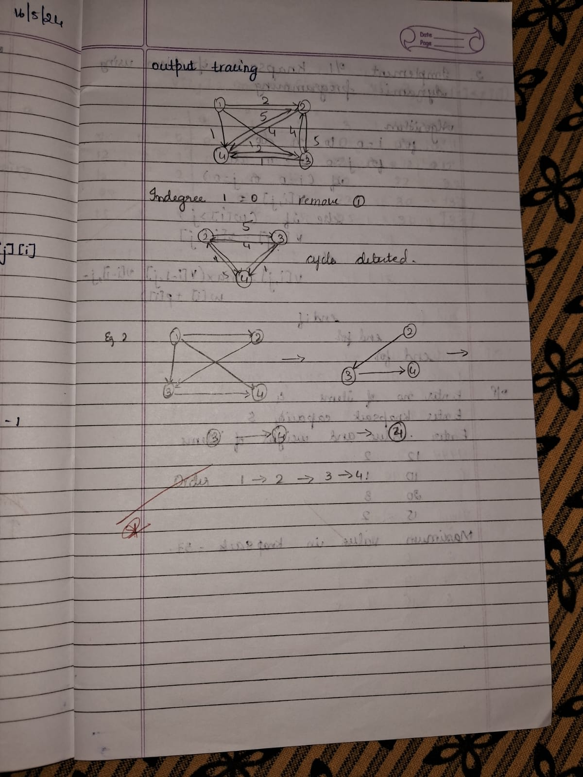

**LEETCODE: Course Schedule Code:**

typedef struct Node { int course;

struct Node *next;

} Node;

void addEdge(Node **graph, int src, int dest) { Node *newNode = (Node *)malloc(sizeof(Node));

newNode->course = dest; newNode->next = graph[src]; graph[src] = newNode;

}

bool canFinish(int numCourses, int** prerequisites, int prerequisitesSize, int* prerequisitesColSize) {

Node **graph = (Node **)calloc(numCourses, sizeof(Node *)); int *indegree = (int *)calloc(numCourses, sizeof(int));

for (int i = 0; i < prerequisitesSize; i++) {

int course = prerequisites[i][0]; int pre = prerequisites[i][1]; addEdge(graph, pre, course); indegree[course]++;

}

int *queue = (int *)malloc(numCourses * sizeof(int)); int front = 0, rear = 0;

for (int i = 0; i < numCourses; i++) { if (indegree[i] == 0) {

queue[rear++] = i;

}

}

int count = 0;

while (front < rear) {

int current = queue[front++]; count++;

Node *temp = graph[current]; while (temp != NULL) {

indegree[temp->course]--;

if (indegree[temp->course] == 0) {

queue[rear++] = temp->course;

}

temp = temp->next;

}

}

for (int i = 0; i < numCourses; i++) { Node *temp = graph[i];

while (temp != NULL) { Node *next = temp->next; free(temp);

temp = next;

}

}

free(graph); free(indegree); free(queue);

return count == numCourses;

}

**Result:**

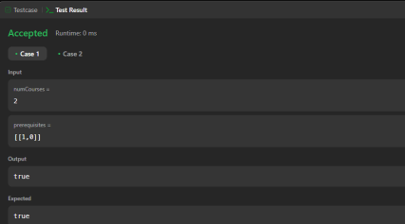

**Lab program 2 :**

**Implement Johnson Trotter algorithm to generate permutations.**

**Code:**

#include <stdio.h> #include <stdlib.h>

void swap(int* a, int* b) { int temp = *a;

*a = *b;

*b = temp;

}

void generatePermutations(int arr[], int start, int end) { if (start == end) {

for (int i = 0; i <= end; i++) { printf("%d ", arr[i]);

}

printf("\n");

} else {

for (int i = start; i <= end; i++) { swap(&arr[start], &arr[i]); generatePermutations(arr, start + 1, end); swap(&arr[start], &arr[i]); // backtrack

}

}

}

int main() { int n;

printf("Enter the number of elements: "); scanf("%d", &n);

int* arr = (int*)malloc(n * sizeof(int)); printf("Enter the elements: ");

for (int i = 0; i < n; i++) { scanf("%d", &arr[i]); }

generatePermutations(arr, 0, n - 1);

free(arr); return 0;

}

**Result:**



**Algorithm and Tracing Screenshot:**

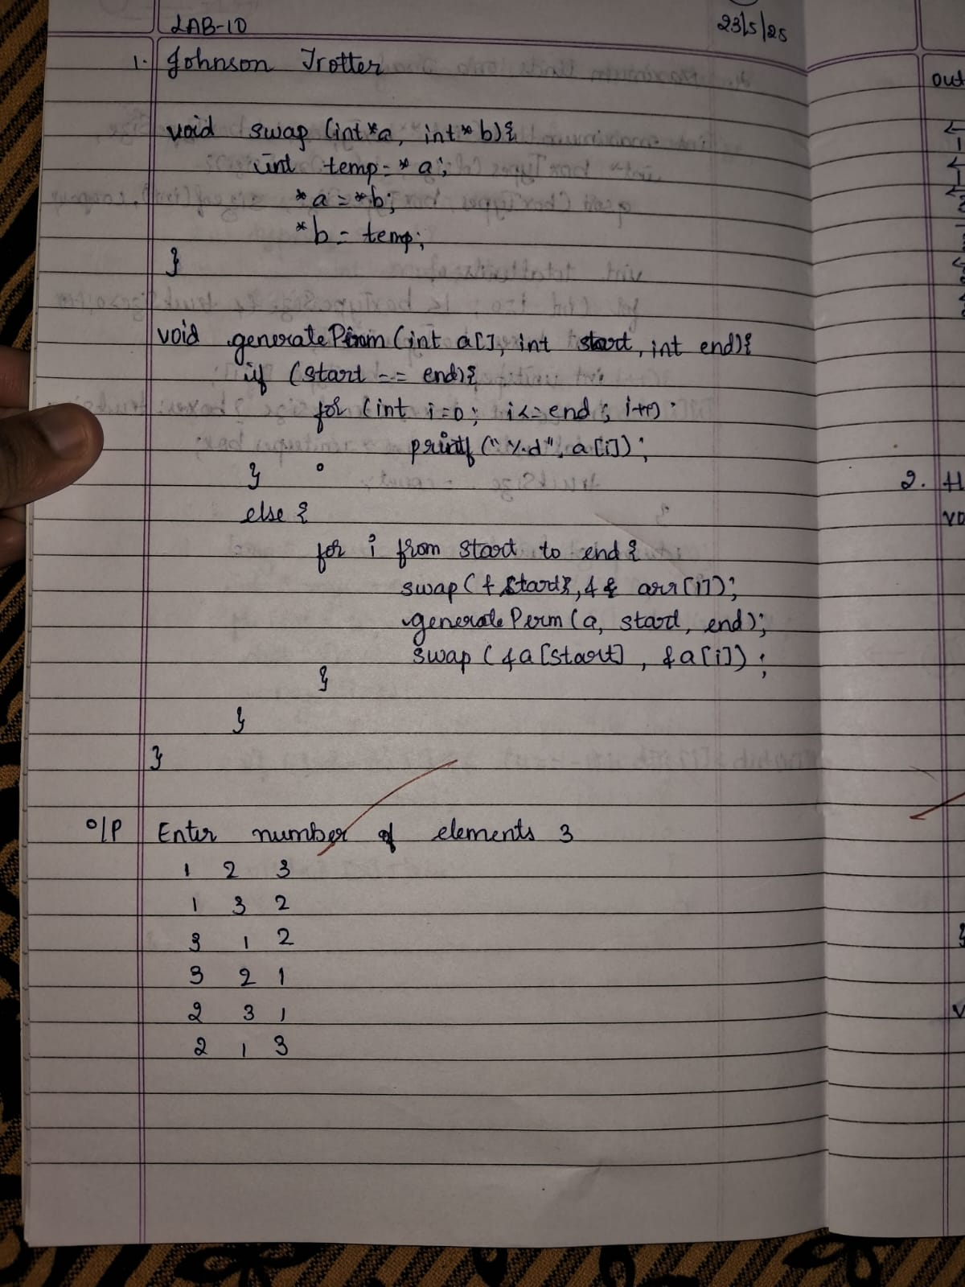

**Lab program 3 :**

**Sort a given set of N integer elements using Merge Sort technique and compute its**

**time taken. Run the program for different values of N and record the time taken to sort.**

**Code:**

#include <stdio.h>

#include <stdlib.h> // for exit #include <time.h> // for clock timing void split(int[], int, int);

void combine(int[], int, int, int); int main() {

int a[15000], n, i, j, ch, temp; clock_t start, end;

while (1) {

printf("\n1: For manual entry of N value and array elements");

printf("\n2: To display time taken for sorting number of elements N in the range 500 to 14500");

printf("\n3: To exit"); printf("\nEnter your choice: "); scanf("%d", &ch);

switch (ch) { case 1:

printf("\nEnter the number of elements: "); scanf("%d", &n);

printf("\nEnter array elements:\n"); for (i = 0; i < n; i++) {

scanf("%d", &a[i]);

}

start = clock(); split(a, 0, n - 1);

end = clock(); printf("\nSorted array is:\n"); for (i = 0; i < n; i++) { printf("%d\t", a[i]);

}

printf("\nTime taken to sort %d numbers is %f Secs\n", n, ((double)(end - start)) / CLOCKS_PER_SEC);

break; case 2:

n = 500;

while (n <= 14500) { for (i = 0; i < n; i++) {

a[i] = n - i; // Reverse order to simulate worst case start = clock();

split(a, 0, n - 1);

// Dummy loop to create consistent delay for (j = 0; j < 500000; j++) {

temp = 38 / 600;

}

end = clock();

printf("\nTime taken to sort %d numbers is %f Secs", n, ((double)(end - start)) / CLOCKS_PER_SEC);

n = n + 1000;

}

break; case 3:

exit(0);

}

} return 0;

}

array void split(int a[], int low, int high) {

int mid;

if (low < high) {

mid = (low + high) / 2; split(a, low, mid); split(a, mid + 1, high);

combine(a, low, mid, high);

}

}

// Function to merge two sorted halves void combine(int a[], int low, int mid, int high) { int c[15000], i, j, k;

i = k = low;

j = mid + 1;

while (i <= mid && j <= high) { if (a[i] < a[j]) {

c[k++] = a[i++];

} else {

c[k++] = a[j++];

}

}

while (i <= mid) { c[k++] = a[i++];

}

while (j <= high) { c[k++] = a[j++];

}

for (i = low; i <= high; i++) { a[i] = c[i];

}

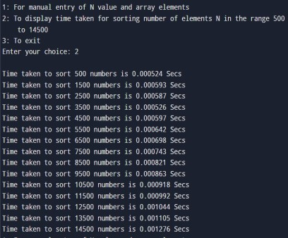**Result:**

**Algorithm and Tracing :**

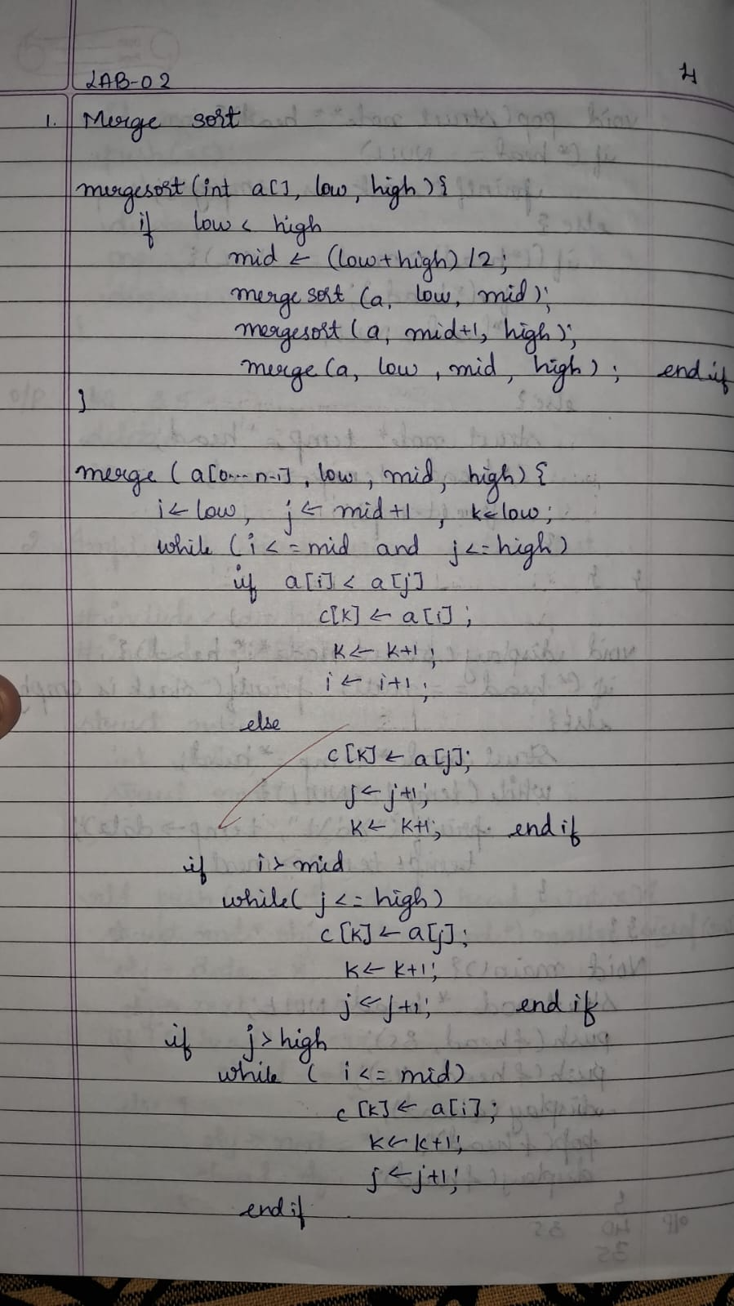 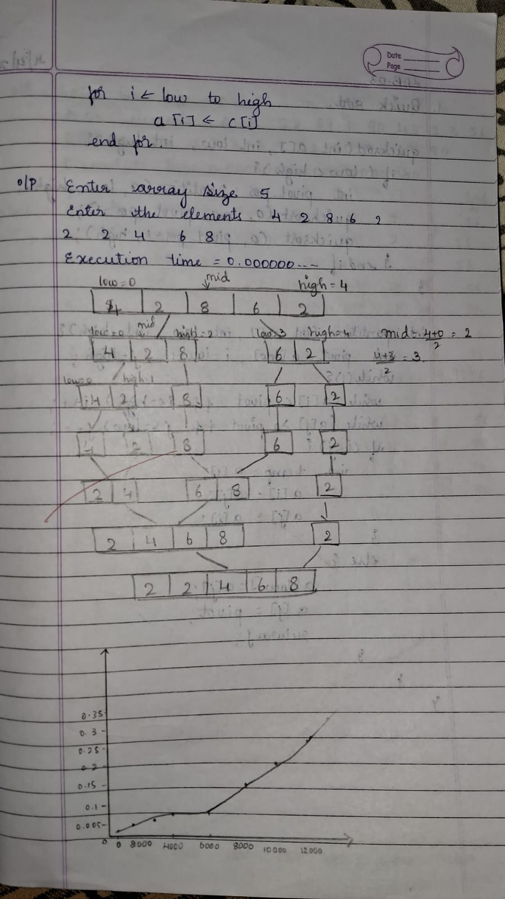

**Lab program 4 :**

**Sort a given set of N integer elements using Quick Sort technique and compute its time taken.**

**Code:**

#include <stdio.h> #include <stdlib.h> #include <time.h>

// Function to swap two elements void swap(int *a, int *b) {

int temp = *a;

*a = *b;

*b = temp;

int partition(int arr[], int low, int high) { int pivot = arr[high]; // pivot element

int i = (low - 1); // index of smaller element

for (int j = low; j < high; j++) { if (arr[j] <= pivot) {

i++;

swap(&arr[i], &arr[j]);

}

}

swap(&arr[i + 1], &arr[high]); return (i + 1);

}

void quickSort(int arr[], int low, int high) { if (low < high) {

int pi = partition(arr, low, high);

quickSort(arr, low, pi - 1);

quickSort(arr, pi + 1, high);

}

} // Main function int main() {

int n; // Input the size of the array printf("Enter number of elements: "); scanf("%d", &n);

int arr[n];

srand(time(0));

printf("Generated array: ");

for (int i = 0; i < n; i++) {

arr[i] = rand() % 1000;

printf("%d ", arr[i]);

}

printf("\n"); // Measure time taken for sorting clock_t start = clock();

quickSort(arr, 0, n - 1);

clock_t end = clock();

double time_taken = ((double)(end - start)) / CLOCKS_PER_SEC;

// Output the sorted array printf("Sorted array: "); for (int i = 0; i < n; i++) {

printf("%d ", arr[i]);

}

printf("\n");

// Output the time taken

printf("Time taken to sort: %f seconds\n", time_taken);

return 0;

}

**Result:**



**Algorithm and Tracing :**

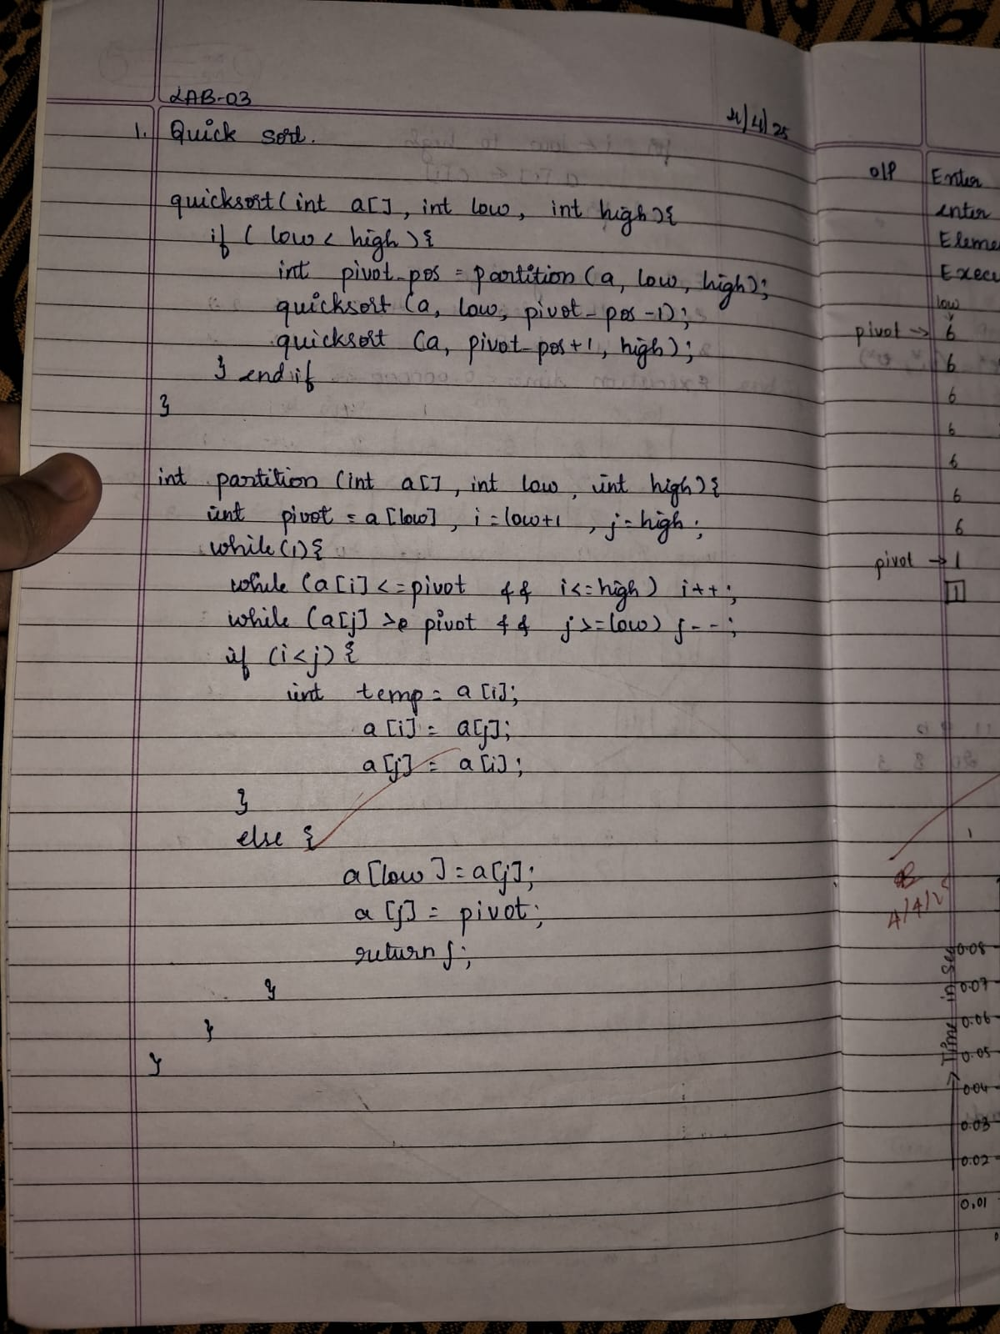 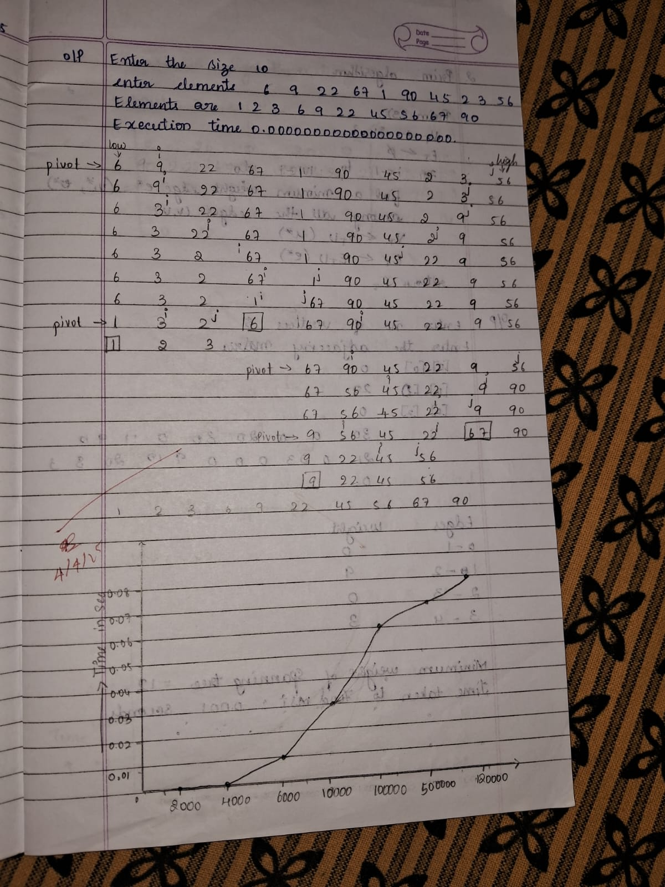

**LEETCODE: 3Sum**

**Code:**

var threeSum = function (nums) { nums.sort((a, b) => a - b);

const op = [];

for (let i = 0; i < nums.length; i++) {

if (i > 0 && nums[i] === nums[i - 1]) continue; const target = -nums[i];

let left = i + 1, right = nums.length - 1; while (left < right) {

const current_sum = nums[left] + nums[right]; if (current_sum === target) {

op.push([nums[i], nums[left], nums[right]]);

while (left < right && nums[left] === nums[left + 1]) left++; while (left < right && nums[right] === nums[right - 1]) right--; left++;

right--;

} else if (current_sum < target) { left++;

} else { right--;

}

}

}

return op;

};

**Result:**

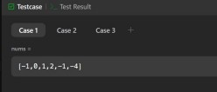

**Lab program 5 :**

**Sort a given set of N integer elements using Heap Sort technique and compute its time taken.**

**Code:**

#include <stdio.h> #include <time.h> #define MAX 1000 int a[MAX];

int n;

void heapify(int a[], int n, int i) { int largest = i;

int left = 2 * i + 1; int right = 2 * i + 2;

if (left < n && a[left] > a[largest]) largest = left;

if (right < n && a[right] > a[largest]) largest = right;

if (largest != i) { int temp = a[i]; a[i] = a[largest]; a[largest] = temp;

heapify(a, n, largest);

}

}

void heapSort(int a[], int n) {

for (int i = n / 2 - 1; i >= 0; i--) heapify(a, n, i);

for (int i = n - 1; i >= 1; i--) { int temp = a[0];

a[0] = a[i]; a[i] = temp;

heapify(a, i, 0);

}

}

int main() { clock_t start, end;

double time_taken;

printf("Enter number of elements: "); scanf("%d", &n);

if (n > MAX) {

printf("Error: Maximum number of elements is %d.\n", MAX); return 1;

}

printf("Enter %d elements:\n", n); for (int i = 0; i < n; i++) scanf("%d", &a[i]);

start = clock();

heapSort(a, n); end = clock();

time_taken = ((double)(end - start)) / CLOCKS_PER_SEC; printf("Sorted array:\n");

for (int i = 0; i < n; i++) printf("%d ", a[i]); printf("\n");

printf("Time taken to sort using Heap Sort: %f seconds\n", time_taken); return 0;

}

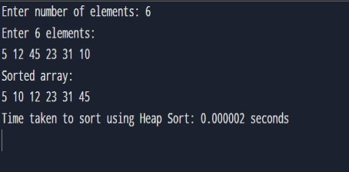**Result:**

**Algorithm and Tracing :**

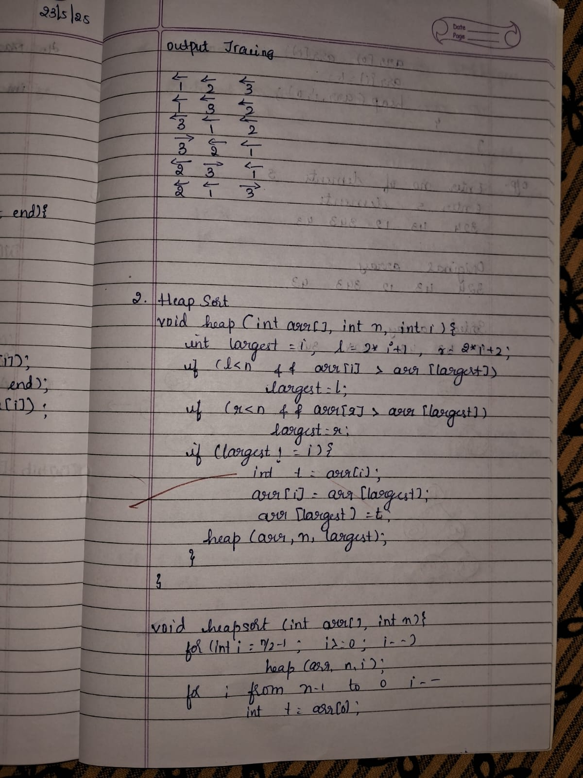 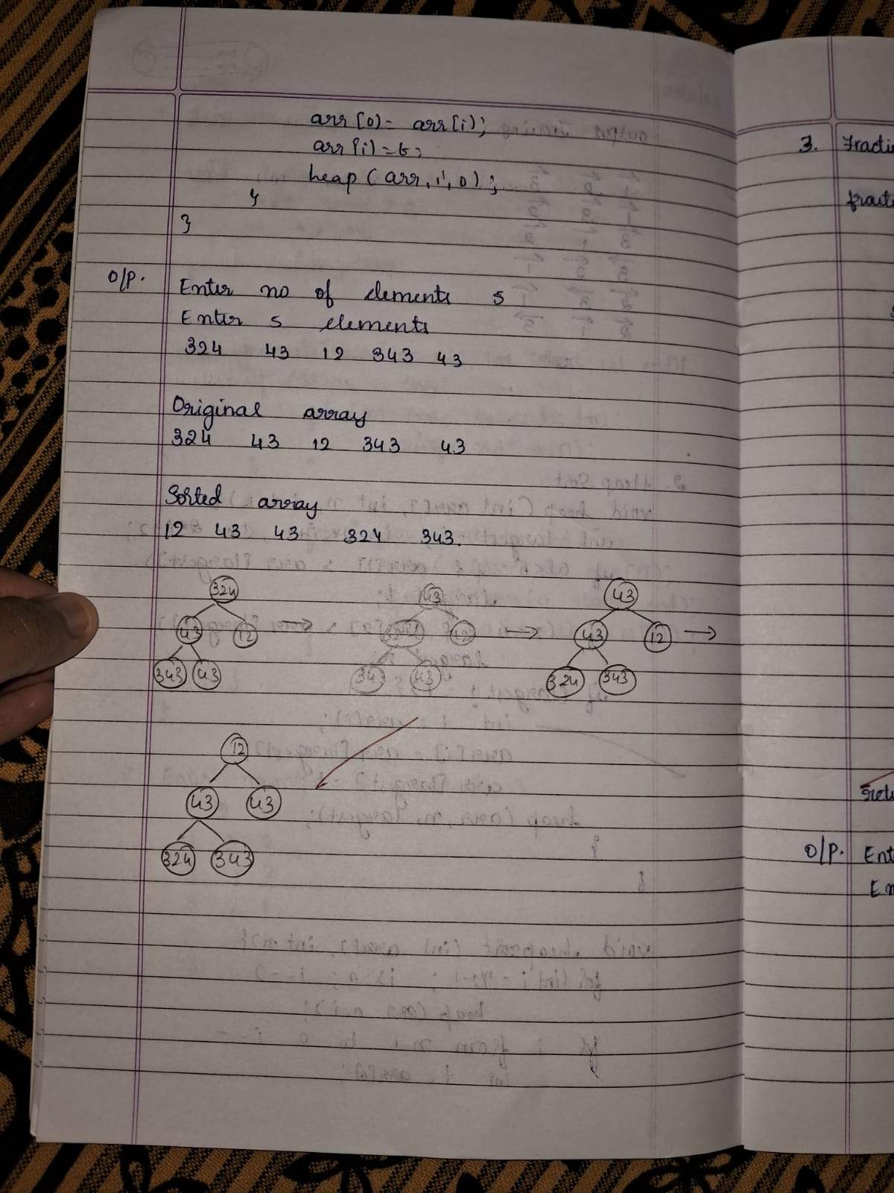

**Lab program 6 :**

**Implement 0/1 Knapsack problem using dynamic programming. Code:**

#include <stdio.h>

int n, m, w[10], p[10], v[11][11];

void knapsack(int, int, int[], int[]); int max(int, int);

int main() { int i, j;

printf("Enter the number of items: ");

scanf("%d", &n);

printf("Enter the capacity of the knapsack: "); scanf("%d", &m);

printf("Enter weights:\n"); for (i = 1; i <= n; i++) { scanf("%d", &w[i]);

}

printf("Enter profits:\n"); for (i = 1; i <= n; i++) { scanf("%d", &p[i]);

}

knapsack(n, m, w, p); printf("\nDP Table:\n"); for (i = 0; i <= n; i++) { for (j = 0; j <= m; j++) { printf("%3d ", v[i][j]);

}

printf("\n");

}

printf("\nOptimal Profit: %d\n", v[n][m]); return 0;

}

void knapsack(int n, int m, int w[], int p[])

{ int i, j;

for (i = 0; i <= n; i++) { for (j = 0; j <= m; j++) { if (i == 0 || j == 0) {

v[i][j] = 0;

} else if (w[i] > j) { v[i][j] = v[i - 1][j];

} else {

v[i][j] = max(v[i - 1][j], v[i - 1][j - w[i]] + p[i]); }}}} int max(int a, int b) {

return (a > b) ? a : b;}

**Result:**

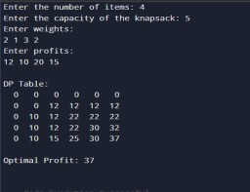

**Algorithm and Tracing:**

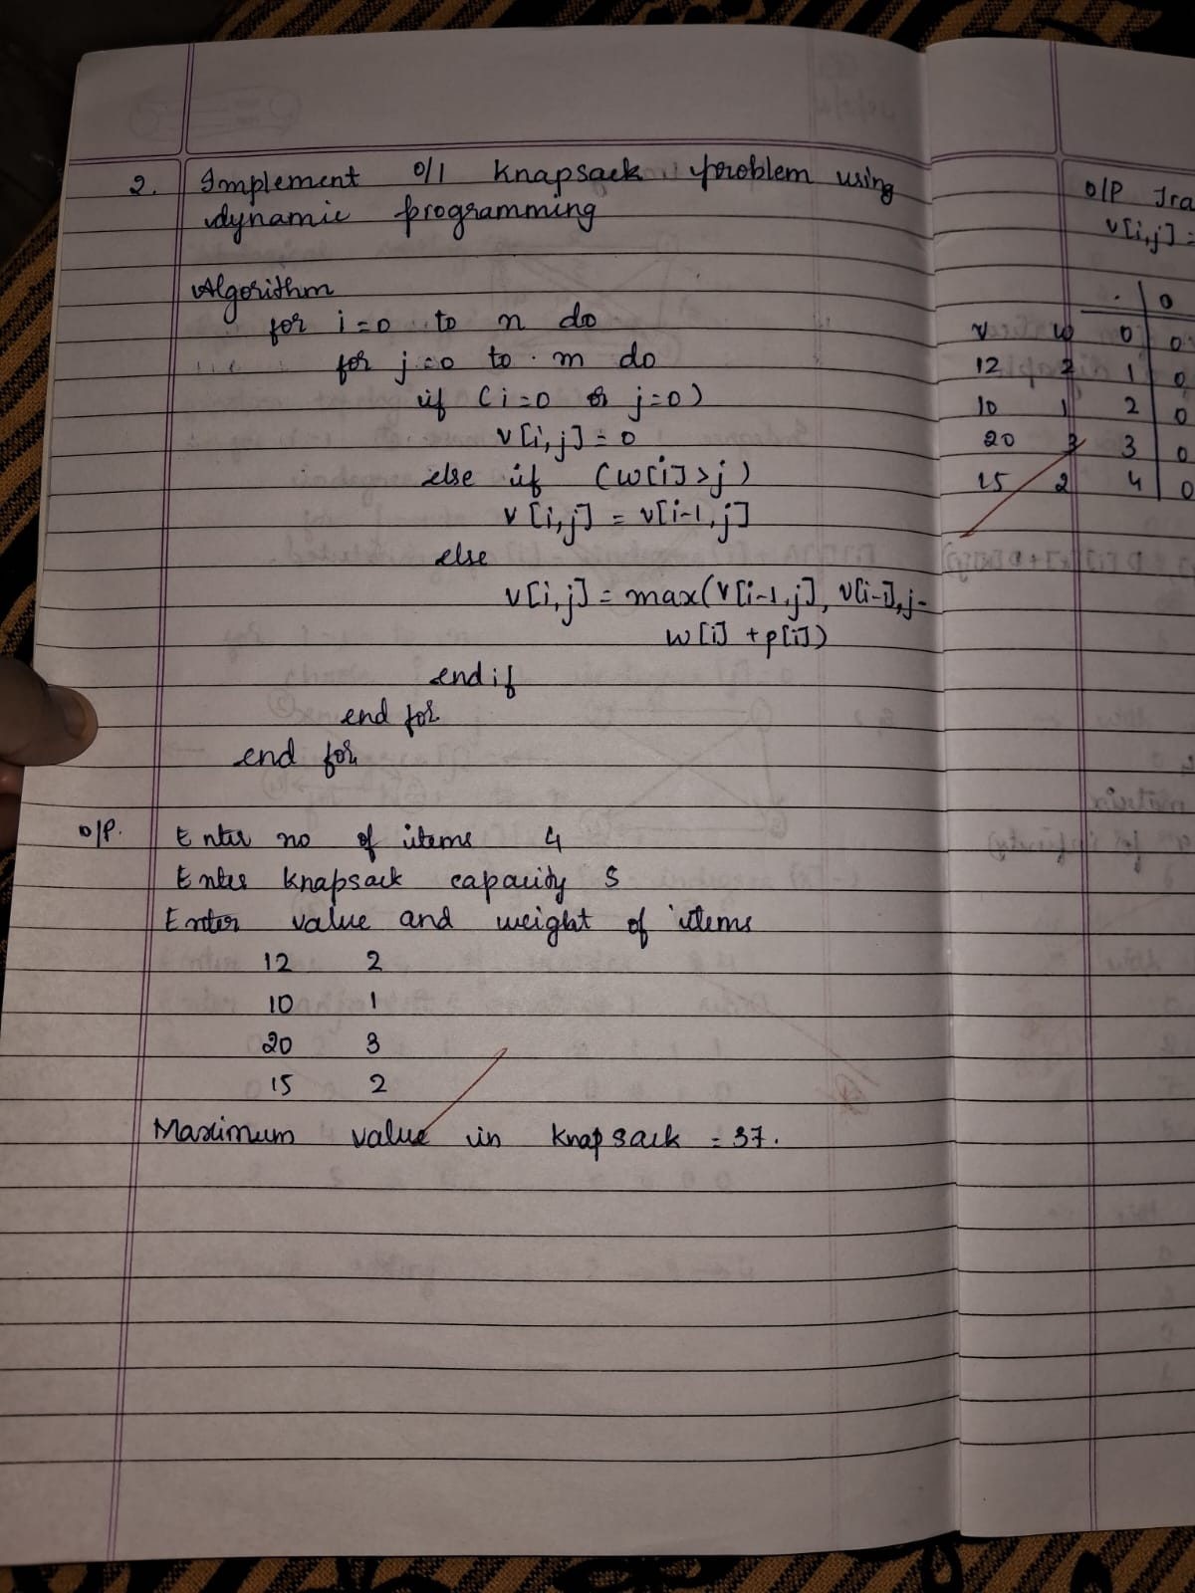 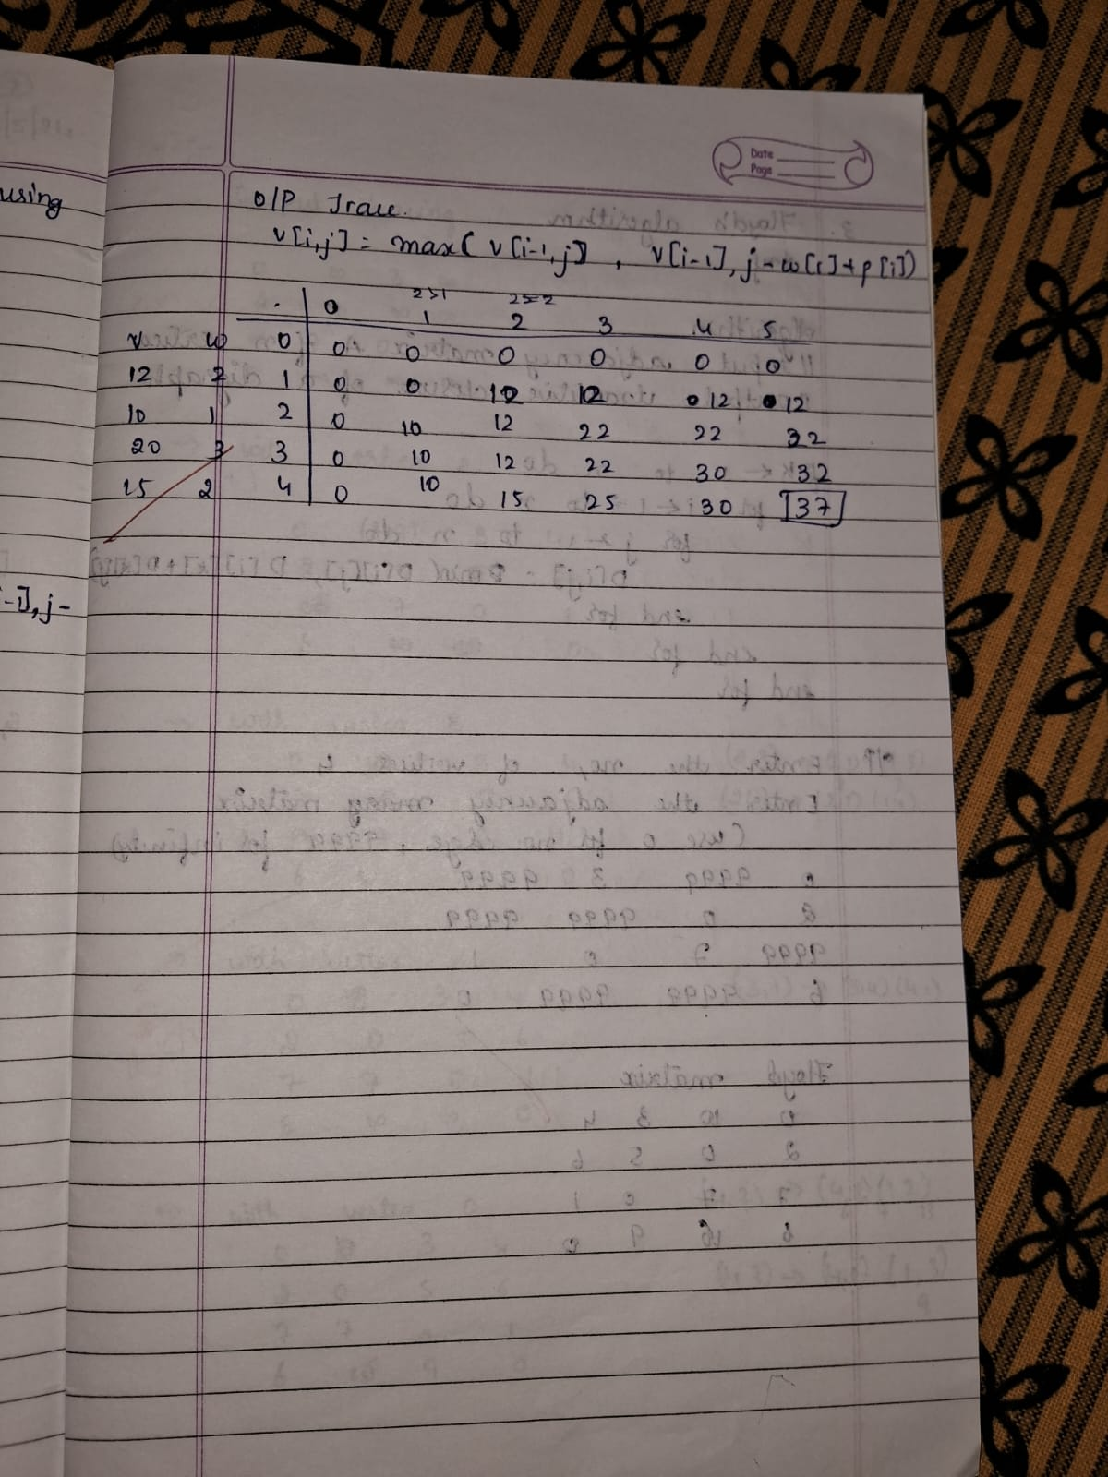

**LEETCODE: Fibonacci Number Code:**

int fib(int n) {

if (n == 0) return 0;

if (n == 1) return 1;

int a = 0, b = 1, c;

// Calculate Fibonacci iteratively for (int i = 2; i <= n; i++) {

c = a + b; // Fibonacci relation

a = b; // Update a to previous b

b = c; // Update b to current Fibonacci number

}

return b; // Return the nth Fibonacci number

}

**Result:**

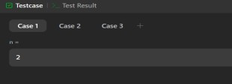

**Lab program 7 :**

**Implement All Pair Shortest paths problem using Floyd’s algorithm. Code:**

#include <stdio.h>

int a[10][10],D[10][10],n;

void floyd(int [][10],int); int min(int,int);

int main()

{

printf("Enter the no. of vertices:"); scanf("%d",&n);

printf("Enter the cost adjacency matrix:\n"); int i,j;

for(i=0;i<n;i++){ for(j=0;j<n;j++){ scanf("%d",&a[i][j]);

}

}

floyd(a,n);

printf("Distance Matrix:\n"); for(i=0;i<n;i++){ for(j=0;j<n;j++){

printf("%d ",D[i][j]);

}

printf("\n");

}

return 0;

}

void floyd(int a[][10],int n){ int i,j,k;

for(i=0;i<n;i++){ for(j=0;j<n;j++){ D[i][j]=a[i][j];

}

}

for(k=0;k<n;k++){ for(i=0;i<n;i++){ for(j=0;j<n;j++){

D[i][j]=min(D[i][j],(D[i][k]+D[k][j]));

} } } }

int min(int a,int b){ if(a<b){

return a;

}else{ return b;

} }

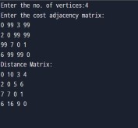**Result:**

**Algorithm and Tracing :**

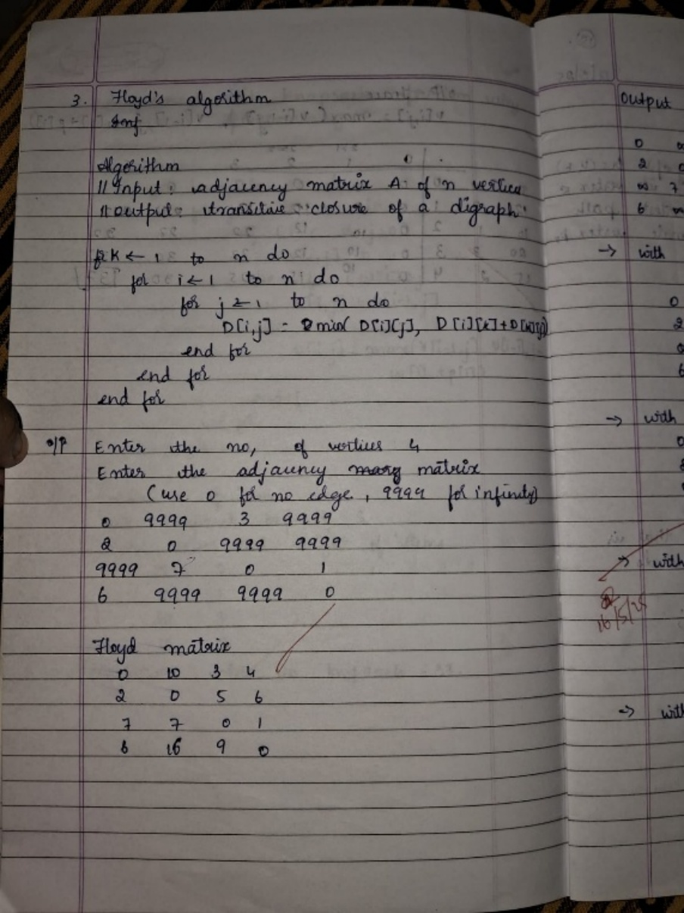 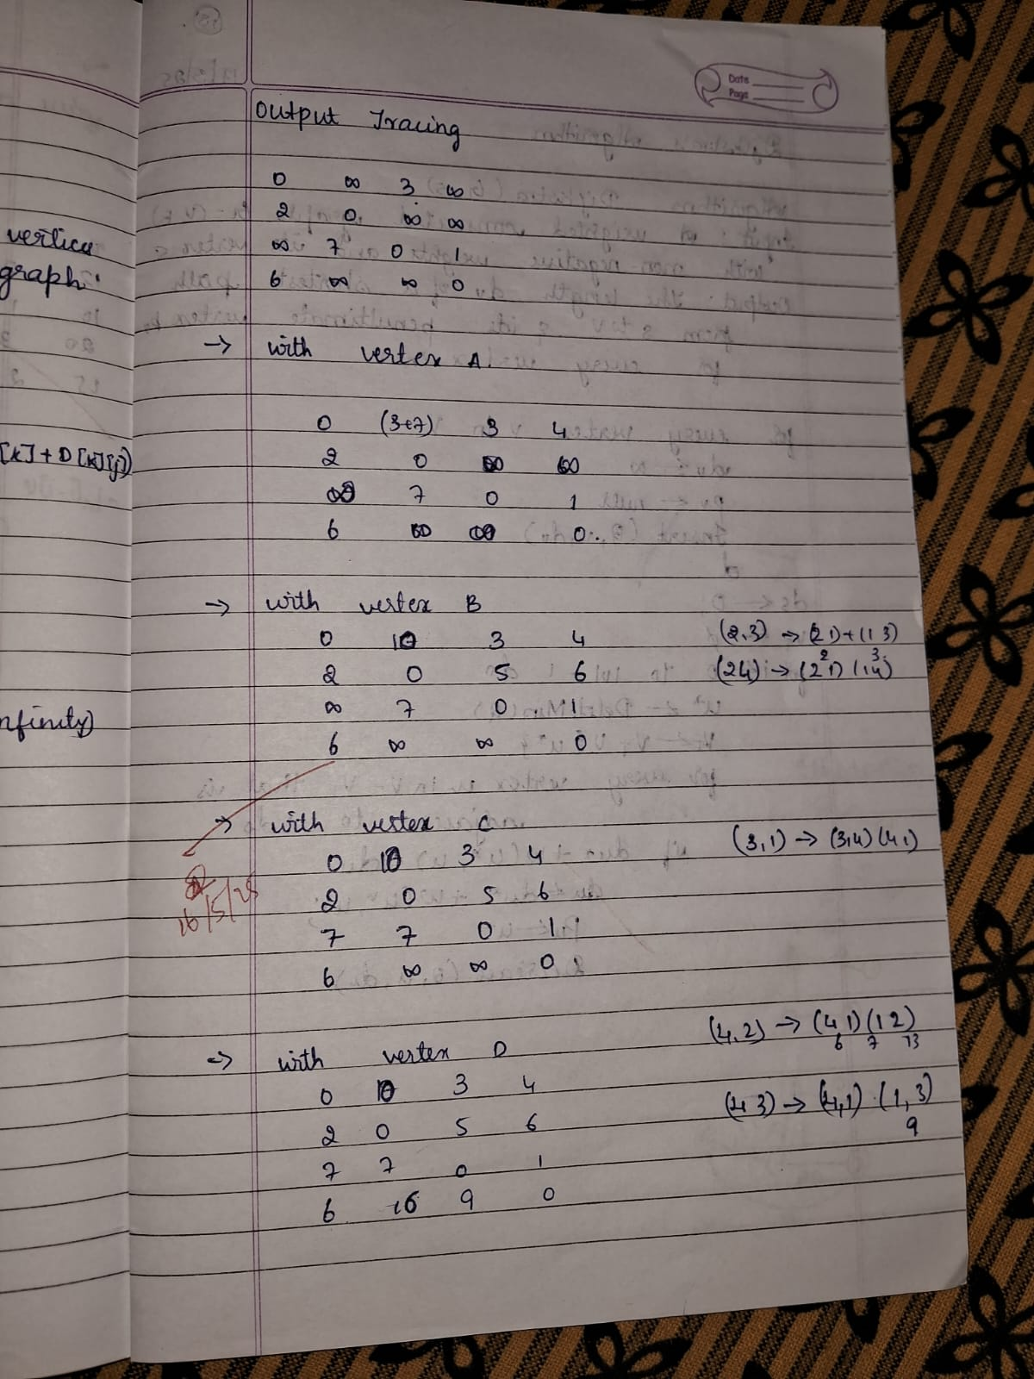

**LEETCODE: Shortest Path Visiting All Nodes Code:** #include <stdio.h>

#include <stdlib.h> #include <string.h> #include <stdbool.h>

#define MAXN 12

#define MAXQ (1 << MAXN) * MAXN

typedefstruct {

int node; int mask; int dist;

} State;

int shortestPathLength(int** graph, int graphSize, int* graphColSize)

{ int allVisited = (1 << graphSize) - 1;

bool visited[MAXN][1 << MAXN] = { false }; State queue[MAXQ];

int front = 0, rear = 0;

// Initialize queue with each node as starting point for (int i = 0; i < graphSize; i++) {

int mask = 1 << i;

queue[rear++] = (State){i, mask, 0}; visited[i][mask] = true;

}

while (front < rear) {

State curr = queue[front++]; if (curr.mask == allVisited) {

return curr.dist;

}

for (int i = 0; i < graphColSize[curr.node]; i++) { int neighbor = graph[curr.node][i];

int nextMask = curr.mask | (1 << neighbor);

if (!visited[neighbor][nextMask]) { visited[neighbor][nextMask] = true;

queue[rear++] = (State){neighbor, nextMask, curr.dist +

1}; }

}

}

return -1; // Should never reach here

}

**Result**

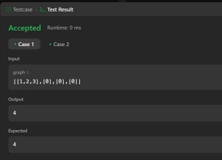

**Lab program 8 :**

**Find Minimum Cost Spanning Tree of a given undirected graph using Prim’s algorithm. Code:**

#include <stdio.h> #define INF 999 int main() {

int n, i, j, min, u, v;

int cost[10][10], visited[10], parent[10], dist[10]; int totalCost = 0;

printf("Enter number of vertices: "); scanf("%d", &n);

printf("Enter cost adjacency matrix (use 999 for no edge):\n");

for (i = 0; i < n; i++) for (j = 0; j < n; j++)

scanf("%d", &cost[i][j]);

// Initialize

for (i = 0; i < n; i++) { dist[i] = cost[0][i]; parent[i] = 0;

visited[i] = 0;

}

visited[0] = 1; // Start from vertex 0 for (i = 1; i < n; i++) {

min = INF; u = -1;

// Find the unvisited vertex with the smallest edge weight

for (j = 0; j < n; j++) {

if (!visited[j] && dist[j] < min) { min = dist[j];

u = j;

}

}

if (u == -1) break; // Graph is disconnected visited[u] = 1;

totalCost += dist[u];

printf("Edge selected: (%d, %d) cost = %d\n", parent[u], u, dist[u]); // Update distance of adjacent vertices

for (v = 0; v < n; v++) {

if (!visited[v] && cost[u][v] < dist[v]) {

dist[v] = cost[u][v]; parent[v] = u;

}

}

}

printf("Total cost of Minimum Spanning Tree: %d\n", totalCost); return 0;

}

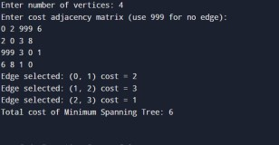**Result:**

**Algorithm and Tracing :**

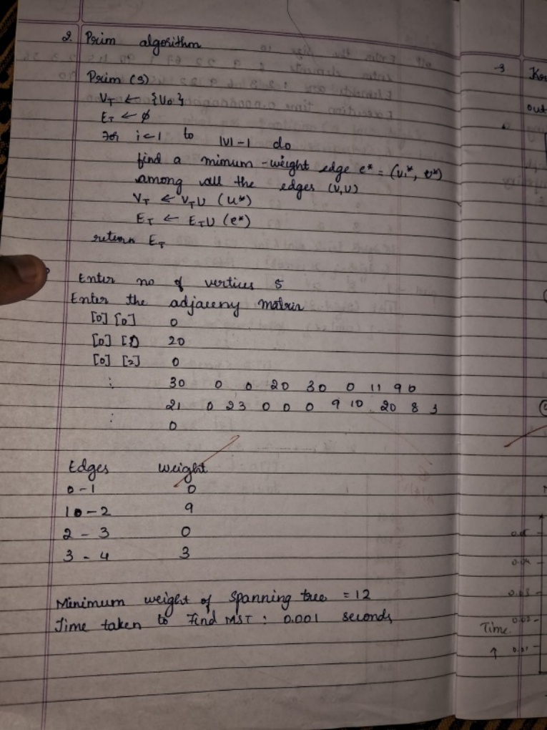 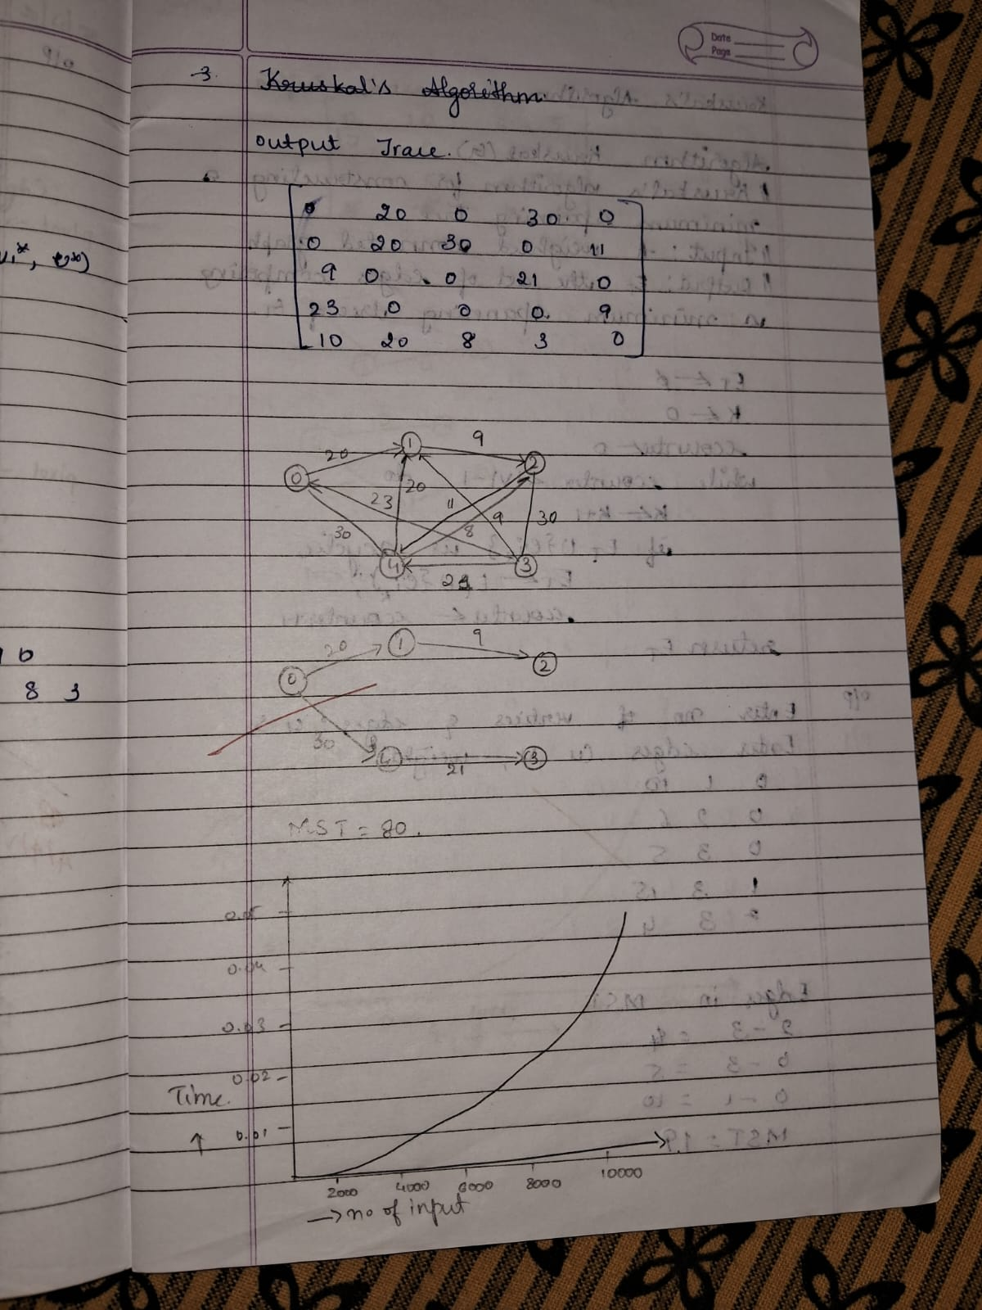

**B. Find Minimum Cost Spanning Tree of a given undirected graph using Kruskal’s algorithm.**

**Code:**

#include <stdio.h>

#define INF 999

int cost[10][10], parent[10]; int n; // Number of vertices

// Function to find the root of a vertex (used in union-find) int find(int i) {

while (parent[i] != i) i = parent[i];

return i;

}

void unionSets(int i, int j) {

int root_i = find(i); int root_j = find(j);

parent[root_i] = root_j;

}

void kruskal() {

int edges = 0, totalCost = 0;

for (int i = 0; i < n; i++)

parent[i] = i;

printf("Edges in the Minimum Spanning Tree:\n"); while (edges < n - 1) {

int min = INF, u = -1, v = -1;

for (int i = 0; i < n; i++) {

for (int j = 0; j < n; j++) {

if (i != j && cost[i][j] < min && find(i) != find(j)) {

min = cost[i][j];

u = i; v = j;

}} }

if (u != -1 && v != -1) { unionSets(u, v);

printf("(%d, %d) -> cost = %d\n", u, v, min); totalCost += min;

edges++;

cost[u][v] = cost[v][u] = INF;

} else {

break; // No valid edge found

} }

printf("Total cost of the Minimum Spanning Tree: %d\n", totalCost);

}

int main() {

printf("Enter the number of vertices: "); scanf("%d", &n);

printf("Enter the cost adjacency matrix (999 for no edge):\n"); for (int i = 0; i < n; i++)

for (int j = 0; j < n; j++) scanf("%d", &cost[i][j]); kruskal();

return 0;

}

**Result:**

**Algorithm and Tracing :**

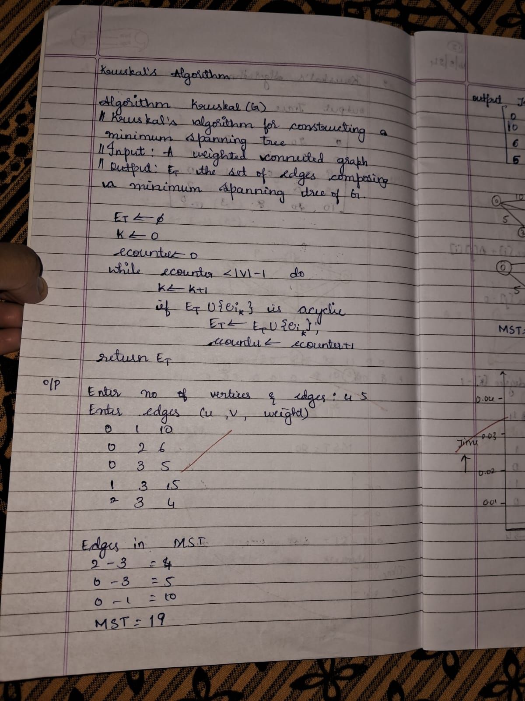 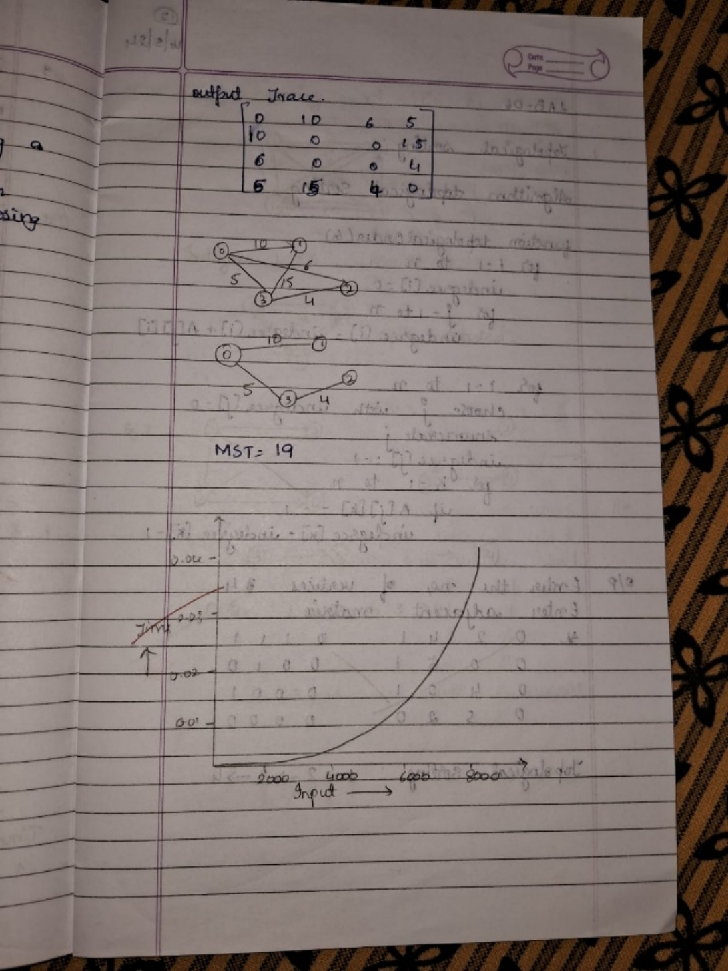

**Lab program 9 :**

**Implement Fractional Knapsack using Greedy technique.**

**Code:**

#include <stdio.h>

void knapsack(int n, int p[], int w[], int W) { int used[n];

for (int i = 0; i < n; ++i)

used[i] = 0;

int cur_w = W; float tot_v = 0.0; int i, maxi;

while (cur_w > 0) { maxi = -1;

for (i = 0; i < n; ++i) { if ((used[i] == 0) &&

((maxi == -1) || ((float)p[i] / w[i] > (float)p[maxi] / w[maxi]))) maxi = i;

}

used[maxi] = 1;

if (w[maxi] <= cur_w) { cur_w -= w[maxi]; tot_v += p[maxi];

printf("Added object %d (%d, %d) completely in the bag. Space left: %d.\n", maxi

+ 1, w[maxi], p[maxi], cur_w);

} else {

int taken = cur_w; cur_w = 0;

tot_v += ((float)taken / w[maxi]) * p[maxi];

printf("Added %d%% (%d, %d) of object %d in the bag.\n", (int)((float)taken / w[maxi] * 100), w[maxi], p[maxi], maxi + 1); }

}

printf("Filled the bag with objects worth %.2f.\n", tot_v);

}

int main() {

int n, W;

printf("Enter the number of objects: "); scanf("%d", &n);

int p[n], w[n];

printf("Enter the profits of the objects: "); for (int i = 0; i < n; i++) {

scanf("%d", &p[i]);

}

printf("Enter the weights of the objects: "); for (int i = 0; i < n; i++) {

scanf("%d", &w[i]);

}

printf("Enter the maximum weight of the bag: "); scanf("%d", &W);

knapsack(n, p, w, W); return 0;

}

**Result:**

**Algorithm and Tracing :**

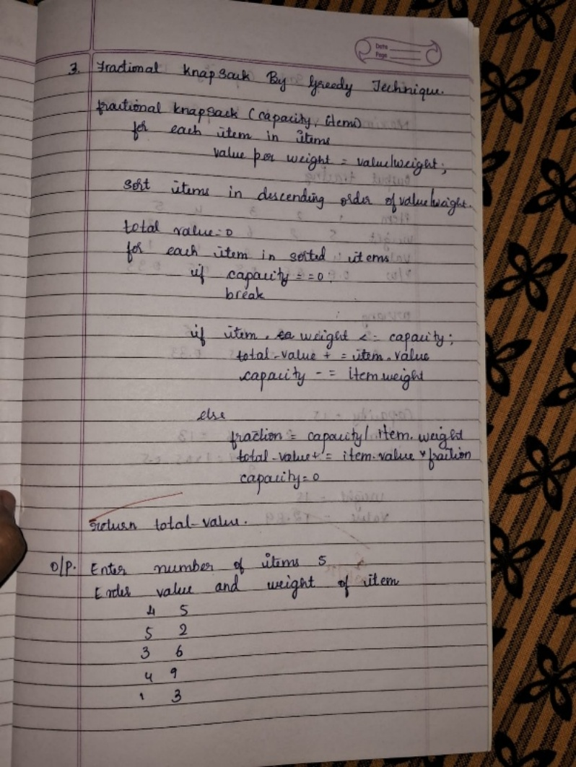 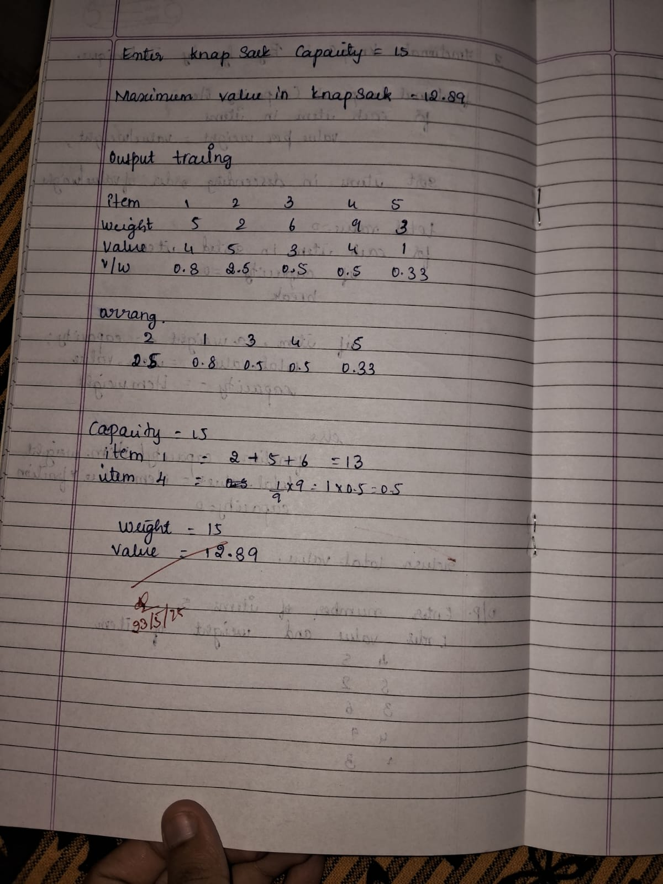

**LEETCODE: Largest Odd Number in String Code:**

char* largestOddNumber(char* num) { int len = strlen(num);

// Traverse from the end to find the rightmost odd digit for (int i = len - 1; i >= 0; i--) {

if ((num[i] - '0') % 2 == 1) {

// Temporarily terminate the string at the right place num[i + 1] = '\0';

return num;

}

}

return ""; // No odd digit found

}

**Result:**

**Lab program 10 :**

**From a given vertex in a weighted connected graph, find shortest paths to other vertices using Dijkstra’s algorithm.**

**Code:**

#include <stdio.h> #define MAX 10

#define INF 999

int cost[MAX][MAX], n, result[MAX][2], weight[MAX]; void dijkstras(int cost[][MAX], int s);

int main() { int i, j, s;

printf("Enter the number of vertices: "); scanf("%d", &n);

if (n > MAX) {

printf("Maximum supported vertices is %d.\n", MAX); return 1;

}

printf("Enter the cost adjacency matrix (use 999 for no edge):\n"); for (i = 0; i < n; i++)

for (j = 0; j < n; j++) scanf("%d", &cost[i][j]);

printf("Enter the source vertex: "); scanf("%d", &s);

dijkstras(cost, s);

printf("\nShortest paths from source vertex %d:\n", s); for (i = 0; i < n; i++) {

if (i != s)

printf("(%d -> %d) with weight %d\n", result[i][0], result[i][1], weight[i]);

}

return 0;

}

void dijkstras(int cost[][MAX], int s) { int d[MAX], visited[MAX], p[MAX]; int i, j, u, v, min;

for (i = 0; i < n; i++) { d[i] = INF;

visited[i] = 0; p[i] = s;

}

d[s] = 0;

for (i = 0; i < n - 1; i++) { min = INF;

u = -1;

// Find unvisited vertex with smallest distance for (j = 0; j < n; j++) {

if (!visited[j] && d[j] < min) { min

= d[j]; u = j;

}

}

if (u == -1) break; visited[u] = 1;

// Update distances

for (v = 0; v < n; v++)

if (!visited[v] && cost[u][v] != INF && d[u] + cost[u][v] < d[v]) { d[v] = d[u] + cost[u][v]; p[v] = u;

}

}

}

// Store the result

for (i = 0; i < n; i++) { result[i][0] = p[i];

result[i][1] = i;

weight[i] = d[i];

}

}

**Result:**

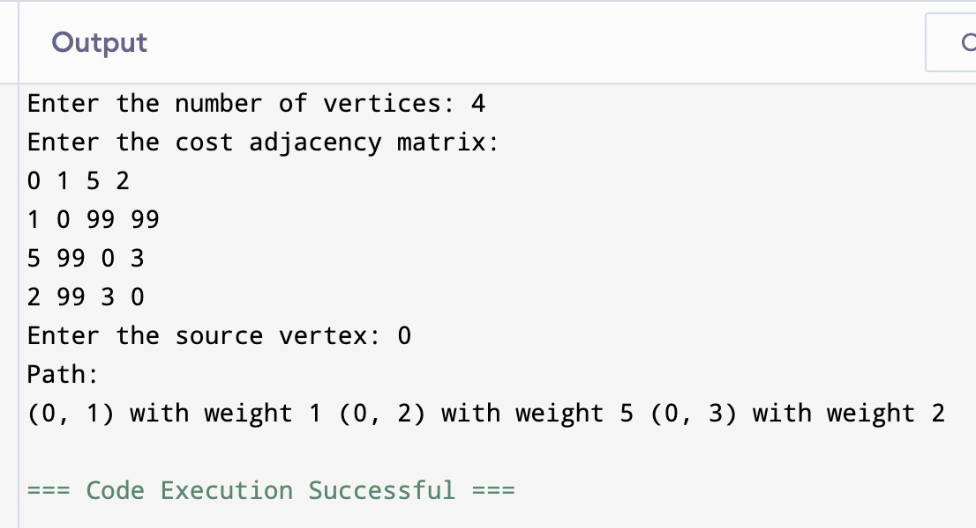

**Algorithm and Tracing :**

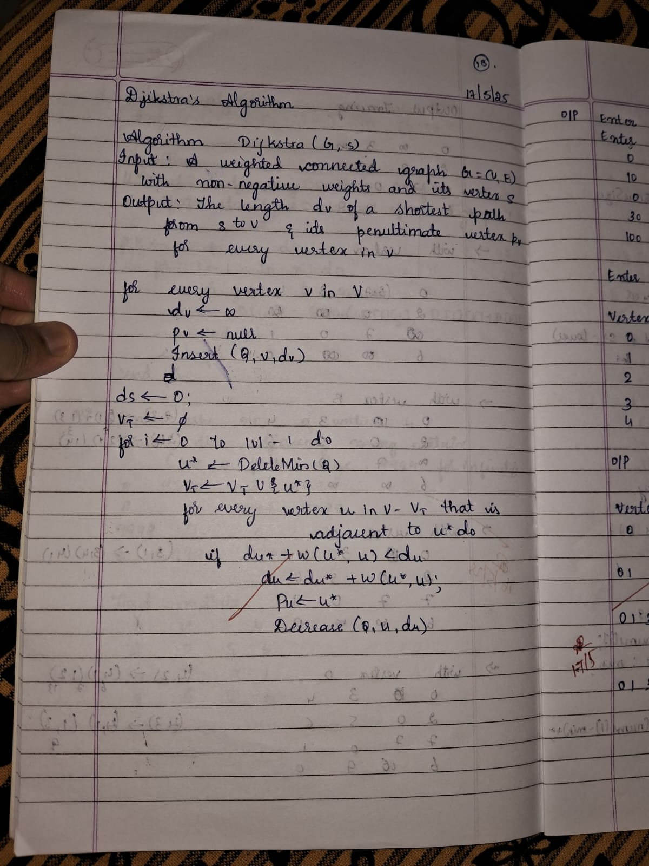 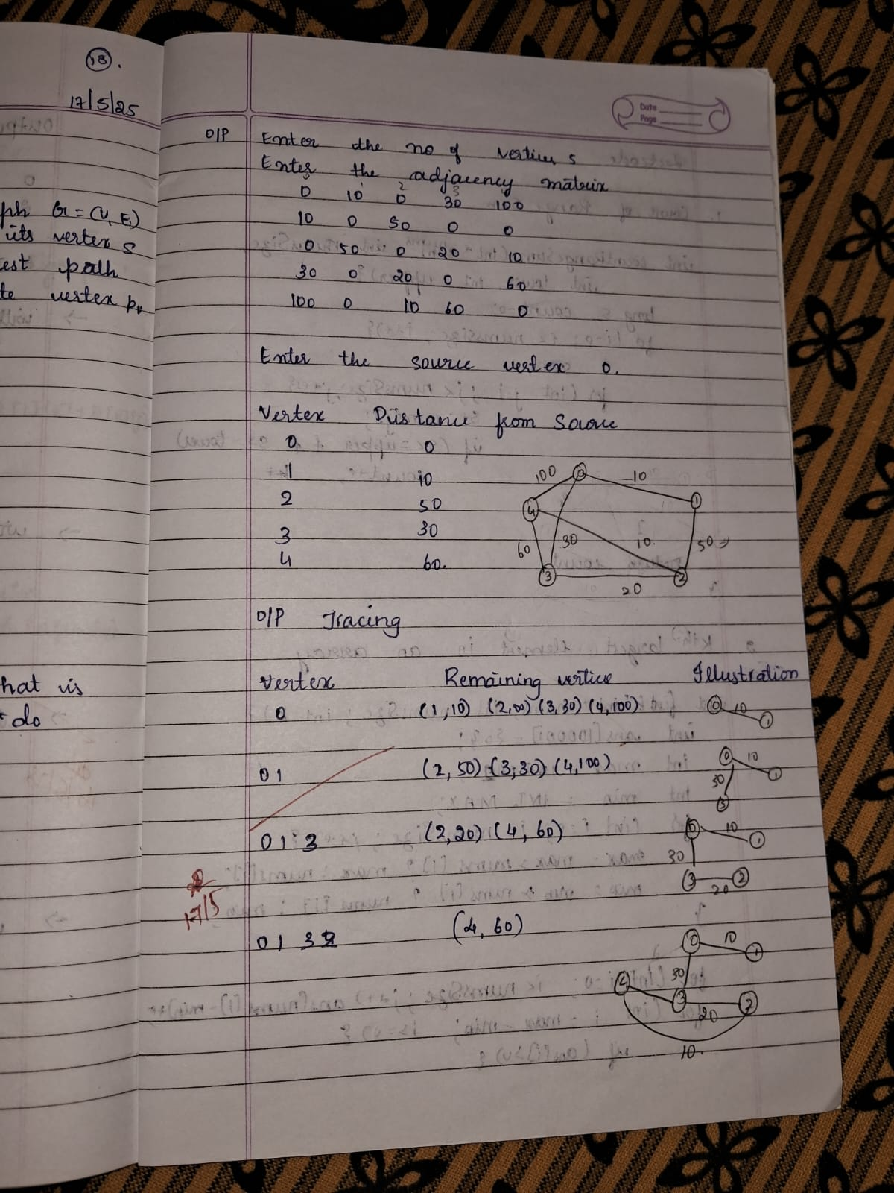

**Lab program 11 :**

**Implement “N-Queens Problem” using Backtracking. Code:**

#include <stdio.h> #include <stdlib.h> #include <stdbool.h>

bool isSafe(int** board, int row, int col, int N)

{ int i, j;

for (i = 0; i < col; i++)

if (board[row][i]) return false;

for (i = row, j = col; i >= 0 && j >= 0; i--, j--) if (board[i][j])

return false;

for (i = row, j = col; j >= 0 && i < N; i++, j--) if (board[i][j])

return false; return true;

}

void printBoard(int** board, int N) { for (int i = 0; i < N; i++) {

for (int j = 0; j < N; j++)

printf("%s ", board[i][j] ? "Q" : "."); printf("\n");

}

printf("\n");

}

void solveNQueensAll(int** board, int col, int N, int* solutionCount)

{ if (col == N) { (*solutionCount)++;

printf("Solution %d:\n", *solutionCount);

printBoard(board, N); return;

}

for (int i = 0; i < N; i++) {

if (isSafe(board, i, col, N)) { board[i][col] = 1;

solveNQueensAll(board, col + 1, N, solutionCount); board[i][col] = 0; // Backtrack

}

}

}

int main() { int N;

printf("Enter the number of queens: "); scanf("%d", &N);

// Dynamically allocate NxN board

int** board = (int**)malloc(N * sizeof(int*)); for (int i = 0; i < N; i++) {

board[i] = (int*)calloc(N, sizeof(int));

}

int solutionCount = 0;

solveNQueensAll(board, 0, N, &solutionCount); if (solutionCount == 0)

printf("No solutions found for %d-Queens.\n", N); else

printf("Total solutions found: %d\n", solutionCount);

// Free allocated memory for (int i = 0; i < N; i++) free(board[i]); free(board);

return 0;

}

**Result:**

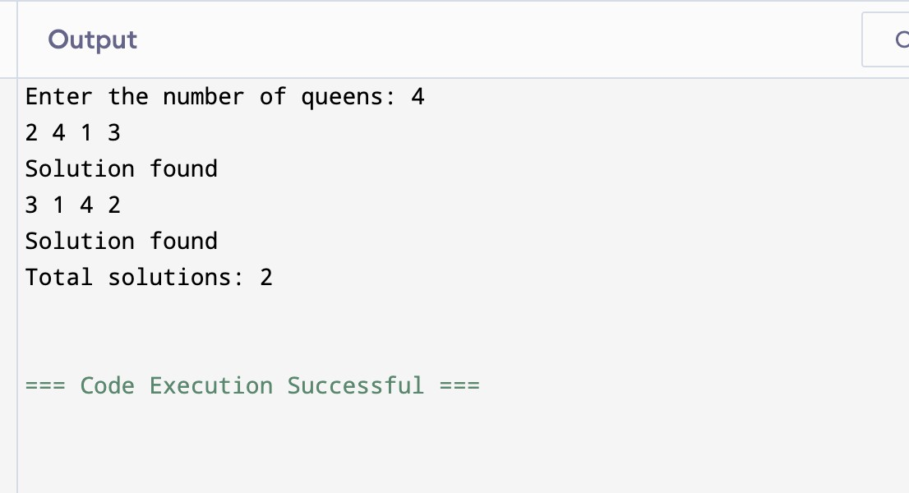

**Algorithm and Tracing :**

